Marketing Sales Dashboard Analysis

From the Power Bi report, we can observe that ROI and profit are high for Influencer campaigns. Though the click rate is less, it is drawing maximum leads. These leads are serious leads, resulting in orders. For the average cost per lead at 500rs, we are getting a profit of 56. This is generating high ROI.

**Influencer Campaigns are providing high ROI**

Click rate is least for Media campaigns. However, these clicks are drawing potential customers resulting in 22% profits.

Click rate is high for Social campaigns, these are drawing leads and orders. The amount being spent per lead is around 570rs that we are getting 60 profit. However, ROI is very less in this case.

Click rate is high for Search campaigns. However, these clicks are drawing very low potential customers resulting in 7% ROI.

Social and influencers campaigns are resulting in high profits. However, the ROI of influencer is high.

**Hence, we can conclude that Influencer campaigns and Social campaigns are Successful.**

**And, Search campaigns are underperforming.**

## Recommendation of optimizing future campaigns:

Profit is high for Social campaigns; however ROI is very less. There could be underlying reasons behind it. I would suggest to look deeper into all the areas where investments are being made. There are some areas which are causing this issue.

The problem is not with the Social campaigns. They are generating good profits.

For future campaigns,

* Media campaigns can be considered as the least have resulted in good profits. We can advertise more in this case, which could result in highly potential customers.
* I would definitely suggest to consider Influencer campaigns.
* Social campaigns can be considered, only in the case where the actual underlying issue could be identified and resolved.
* It would be beneficial to the company to drop Search campaigns.

**We are referencing to below campaigns when we talk about different categories.**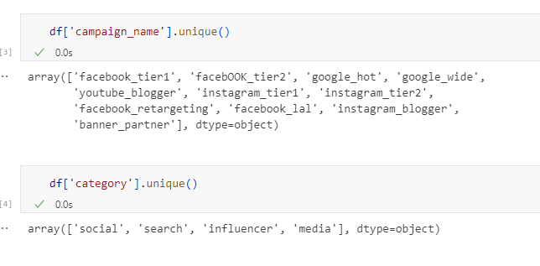

From the above image, we can understand that

* social refers to facebook
* search refers to google
* influencer refers to instagram and youtube
* media refers to banner partner